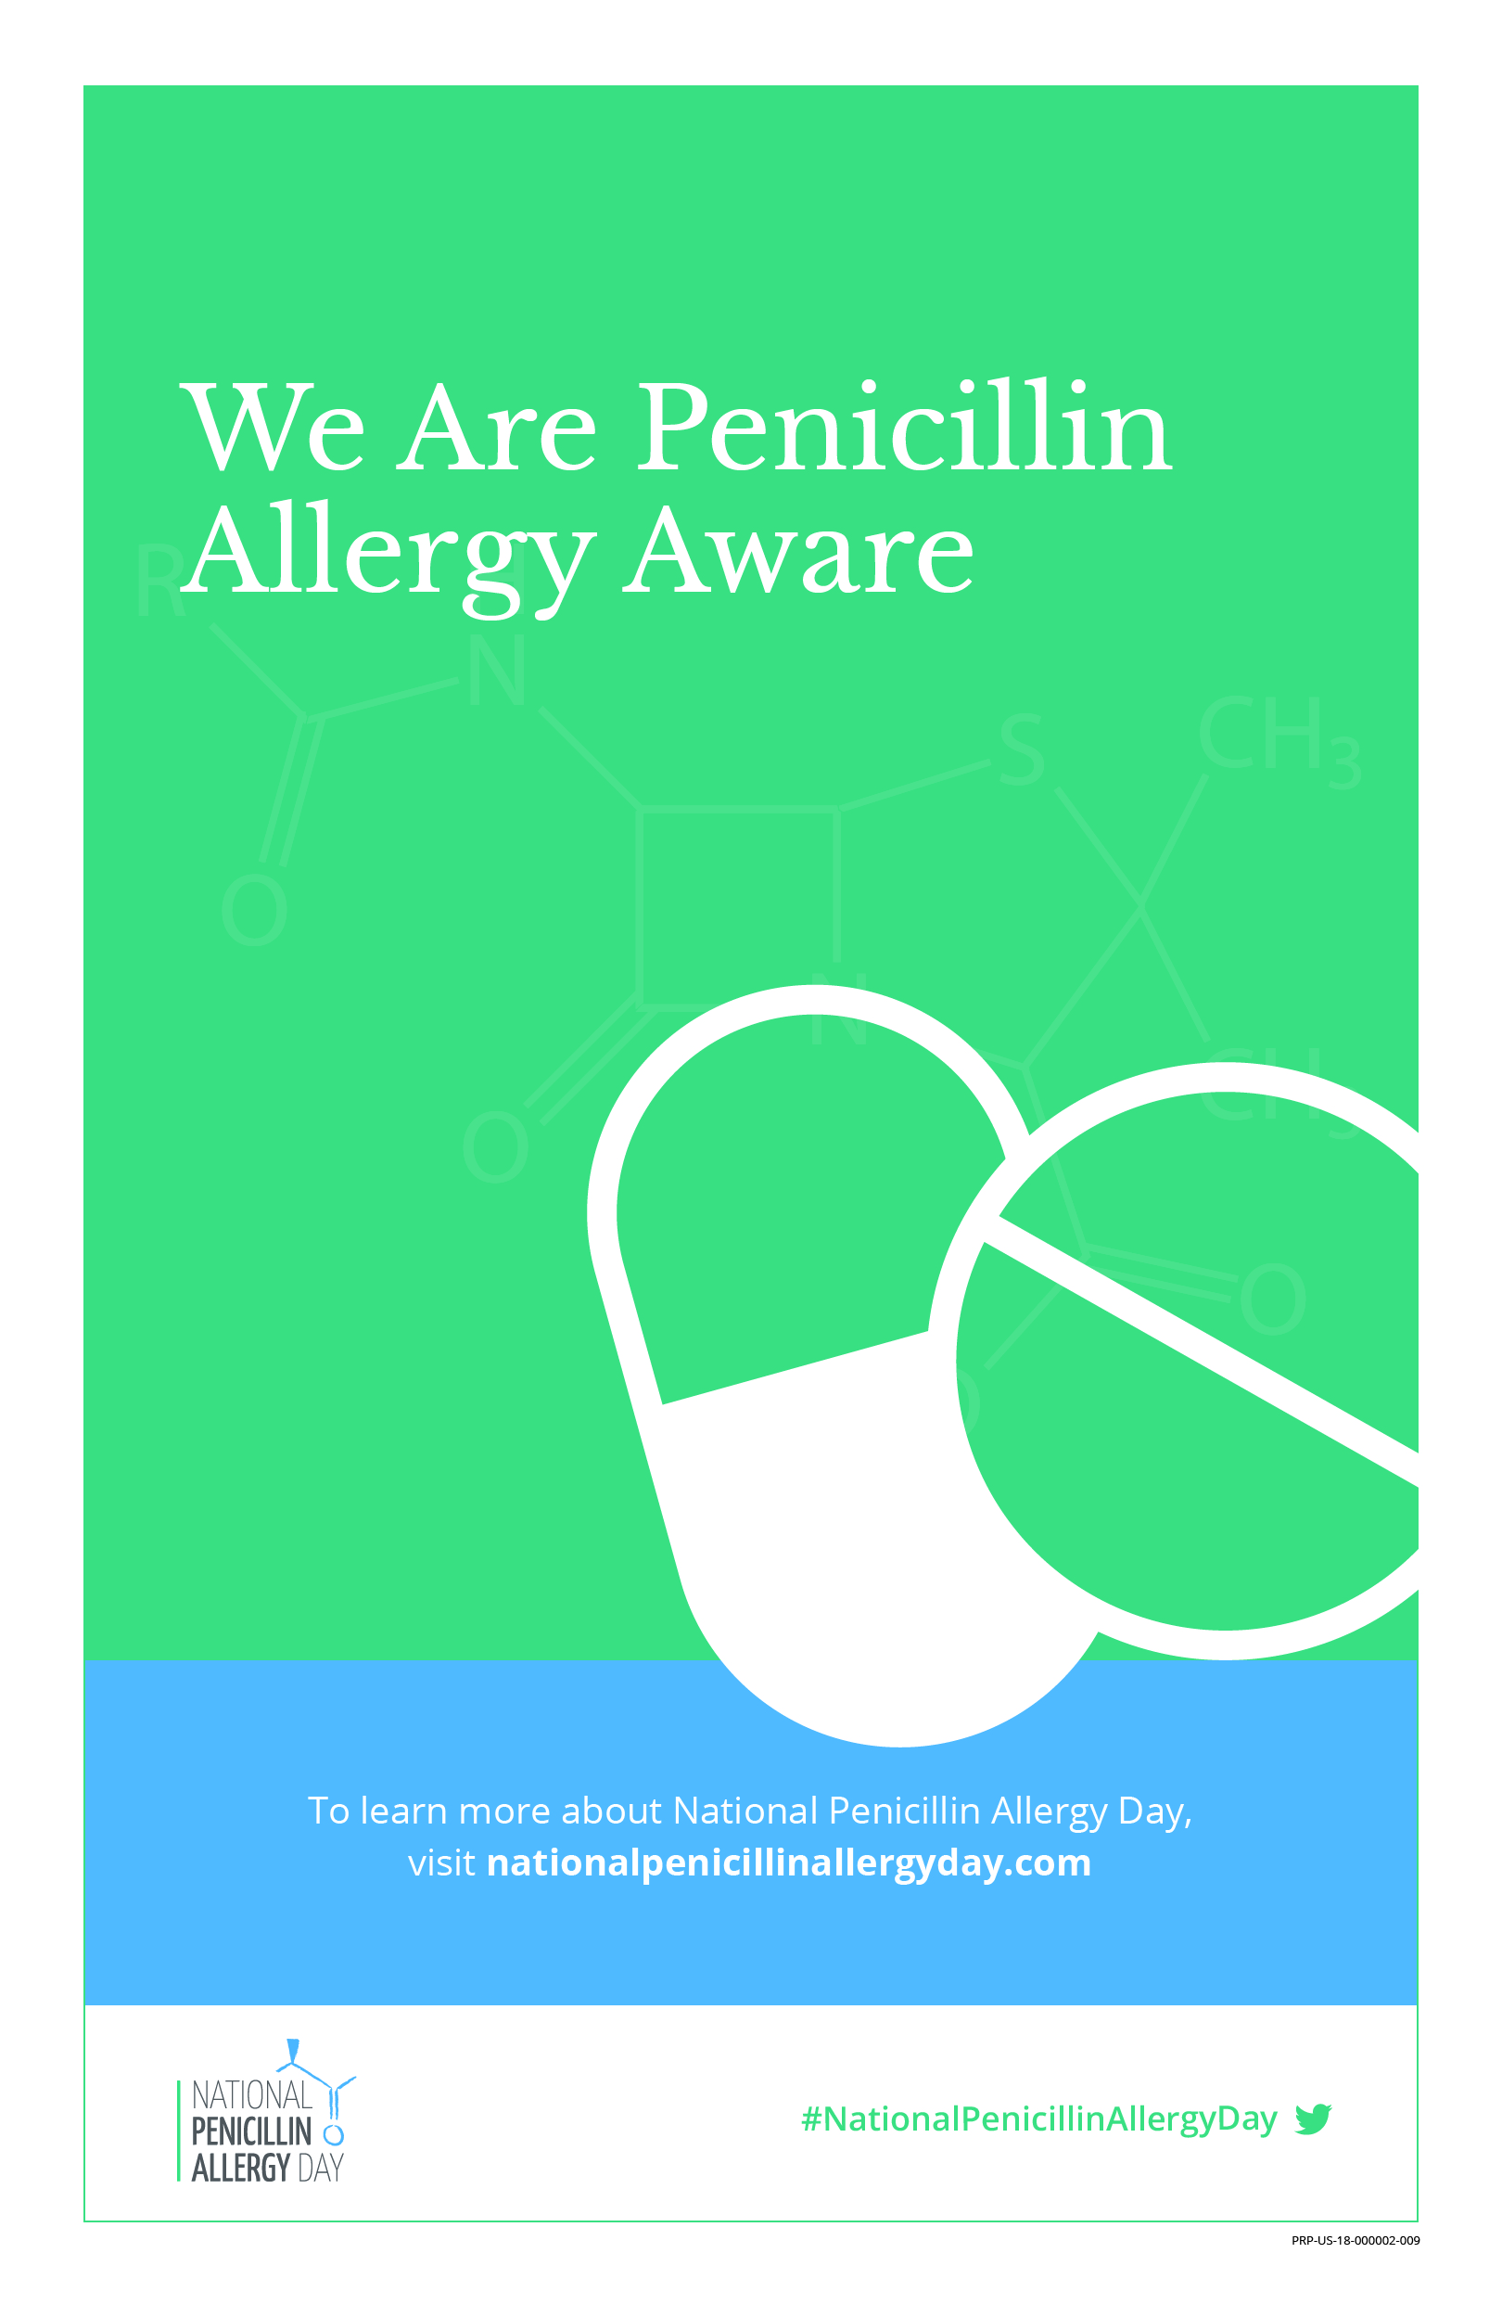­

As of [DATE], we have assessed

**[#] penicillin allergic patients,**

leading to improved antibiotic selection for

**[#] patients**.